**Scanning a site using urlscan.io**

1. Scanning TryHackMe Website

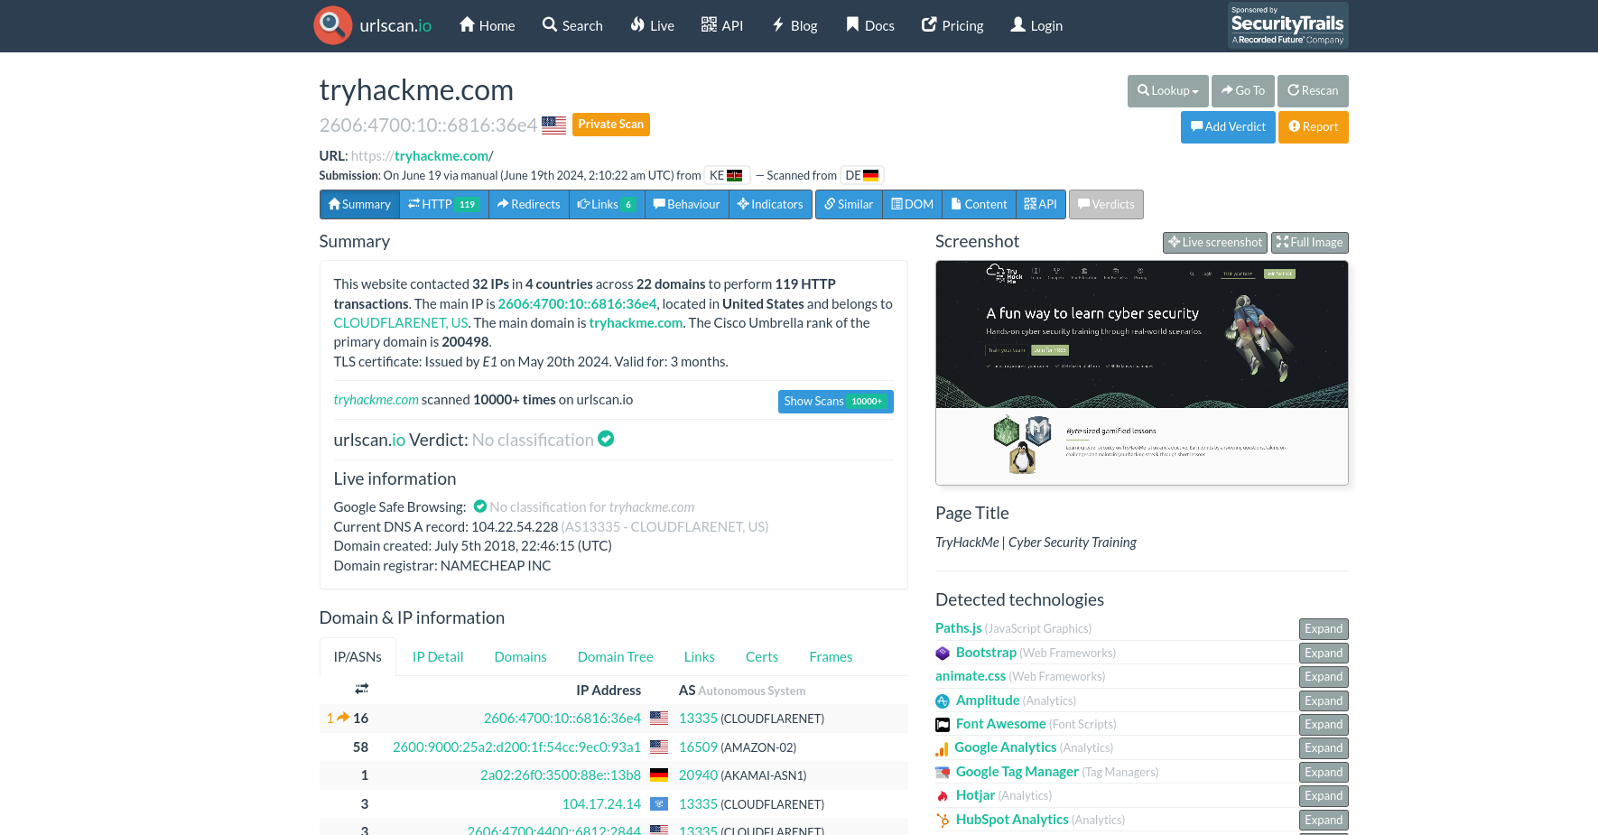

The scan is an private scan.

The Cisco Umbrella Rank for TryHackMe at the time of scanning is 200498.

1. Scanning ShinySearch Website. A prank website for fake popular sites.

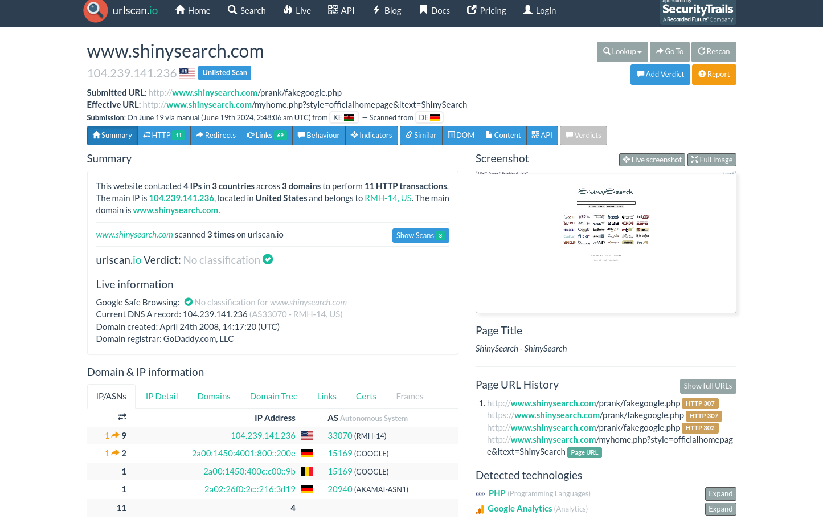

Here is the full image screenshot:

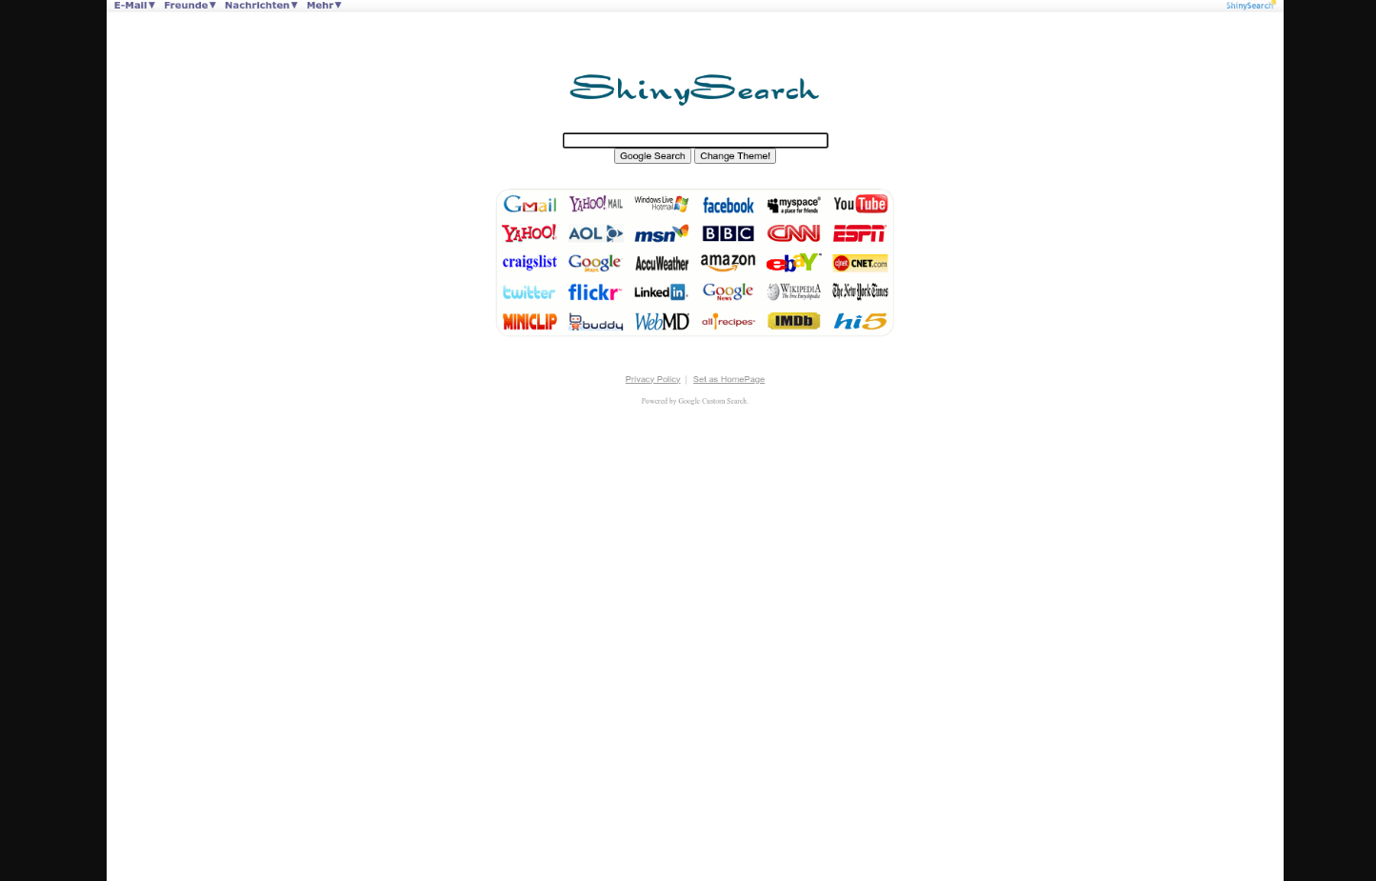

Here’s a lookup if it has been flagged in VirusTotal. Domain is not flagged by any security vendor as malicious:

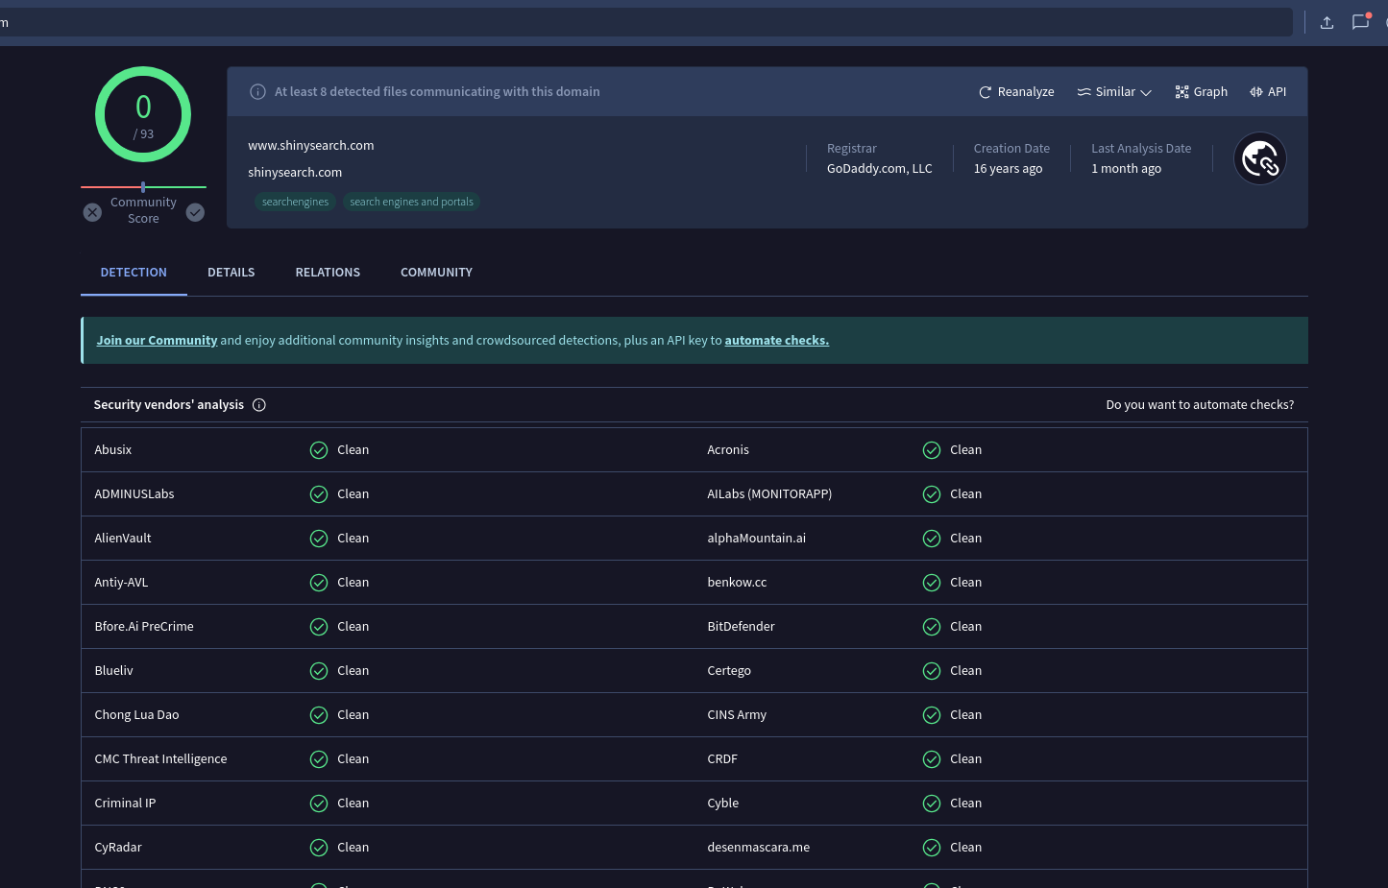

For IP lookup in VirusTotal, 5 files detected communicating with ShinySearch IP. IP remains unrated by security vendors’ if malicious or clean.

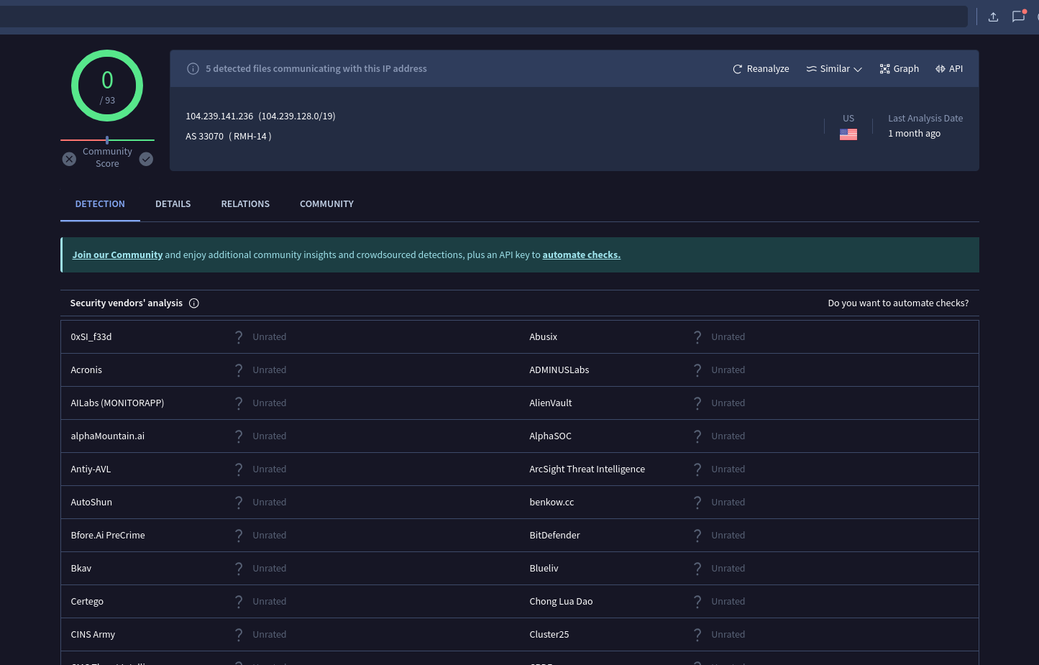

Whois lookup gives the following information:

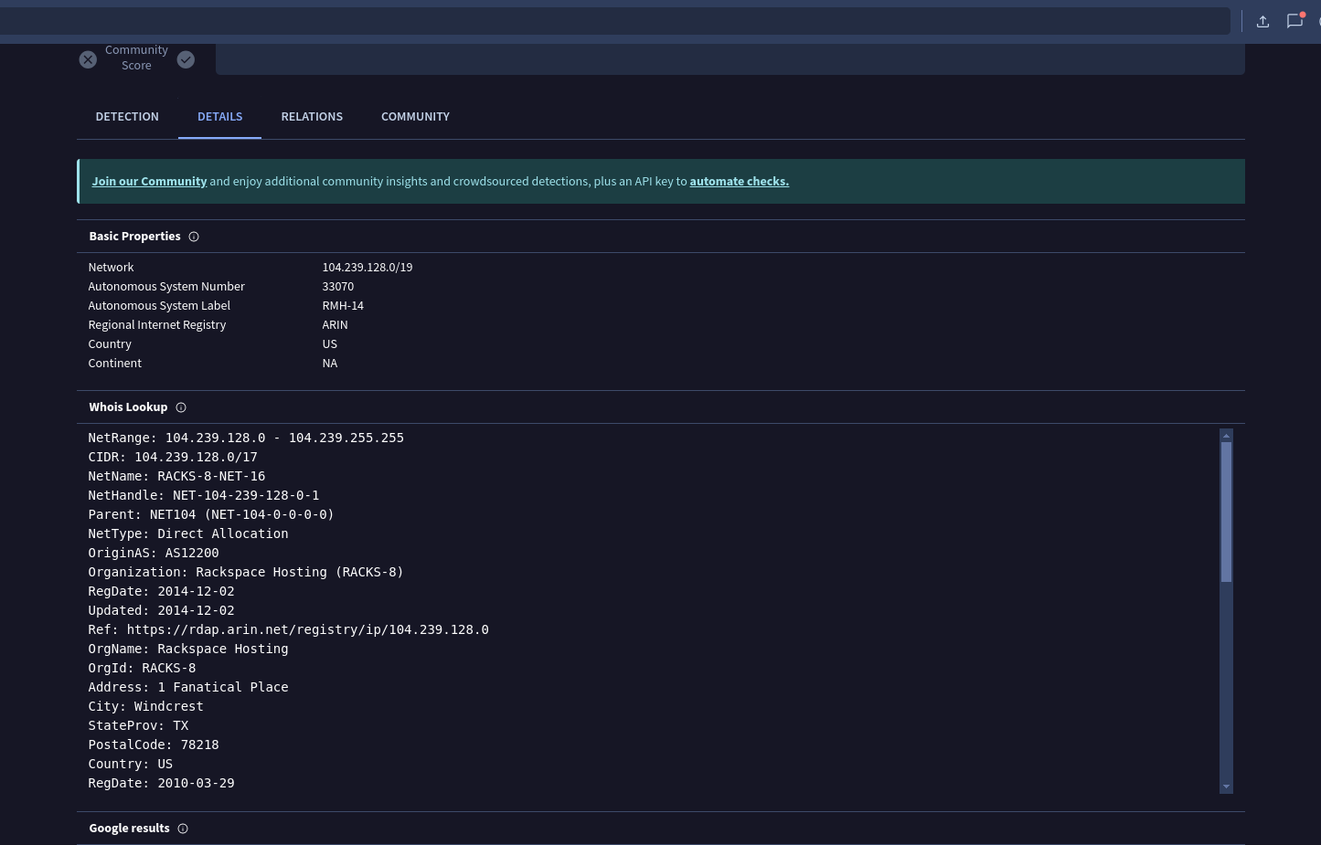

IP appears to be potentially non-malicious. Communicating files detected appear to be potentially malicious.

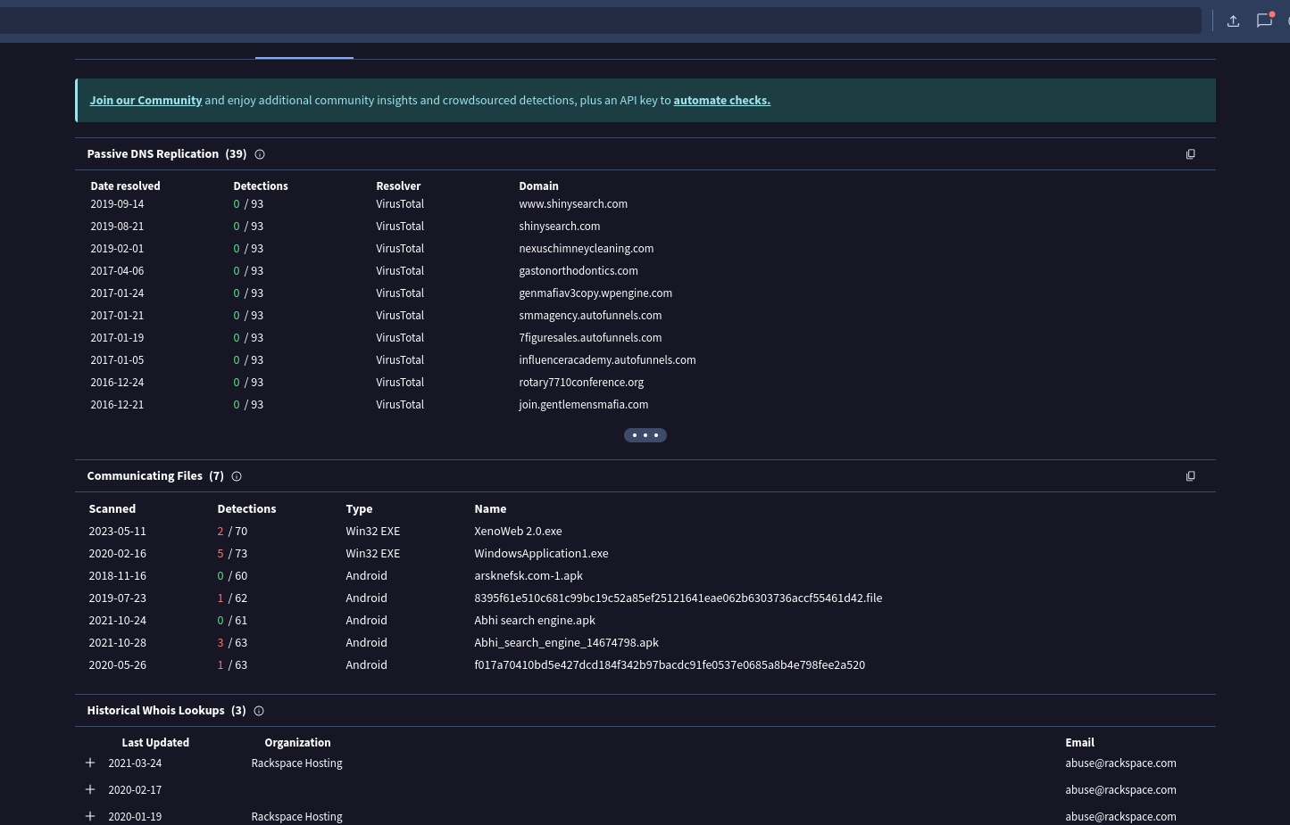

A further analysis of the detections confirm that all potential malware files communicating with the IP are from ShinySearch.

ShinySearch identifies itself as providing fake prank information for pranking family and friends.

Analysis of detections provide reasonable conclusions for files to be false-positives.

File 1

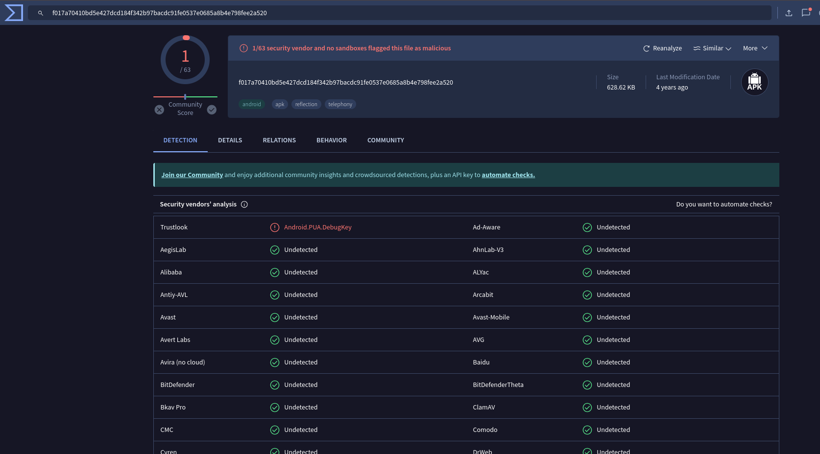

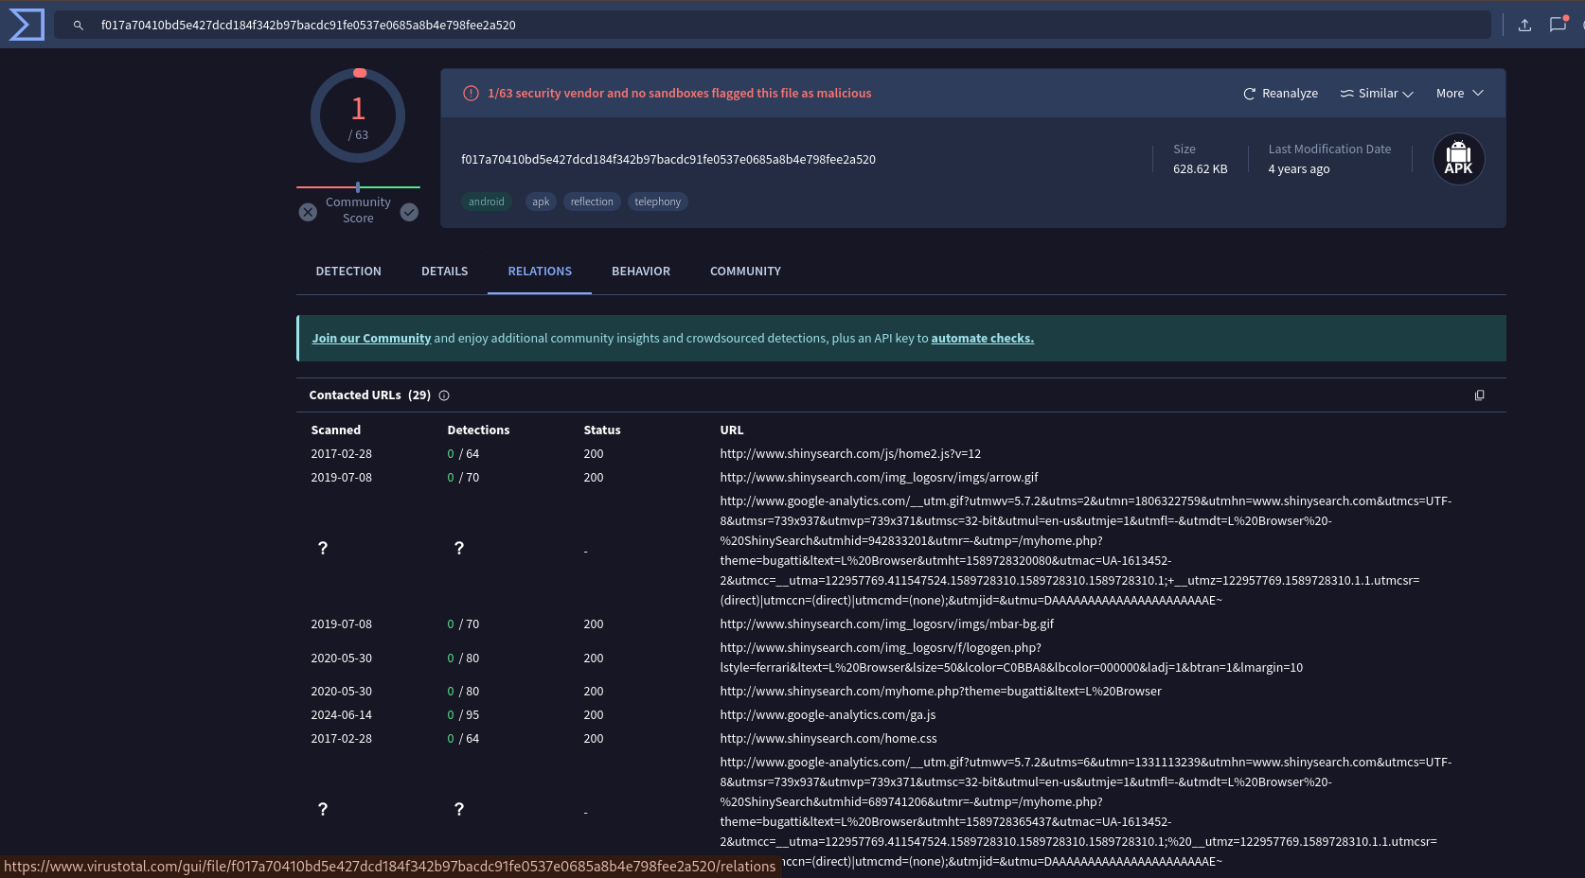

File 2

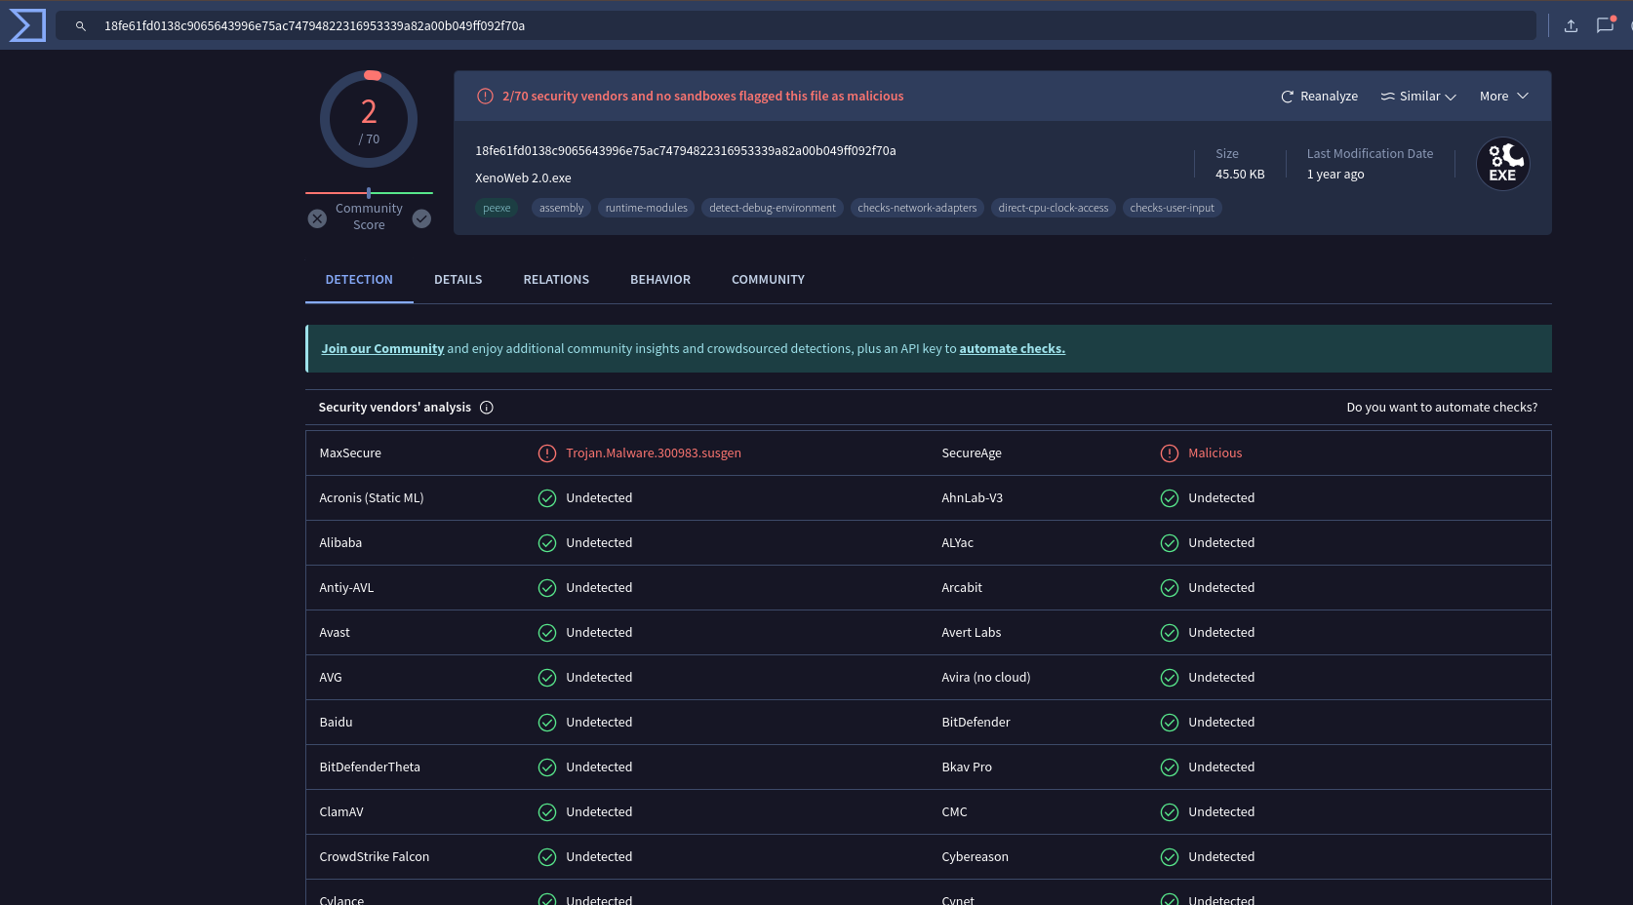

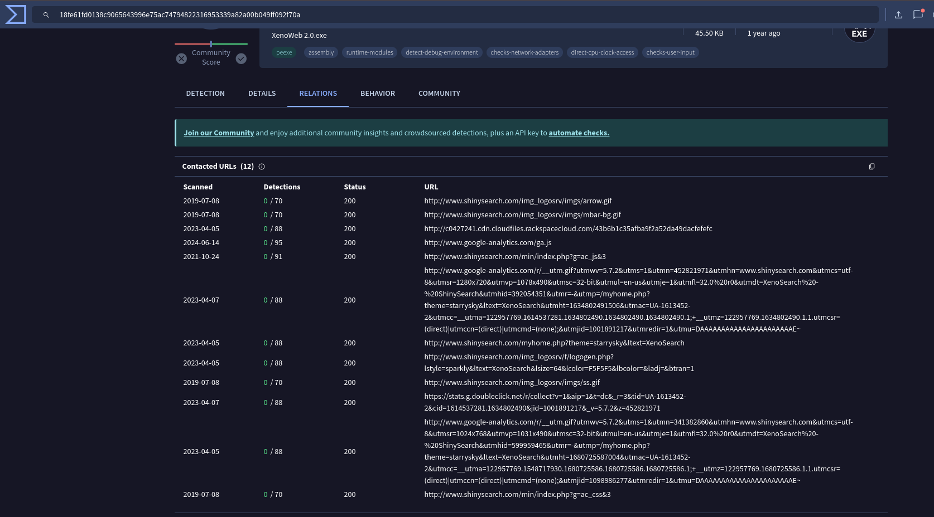

File 3

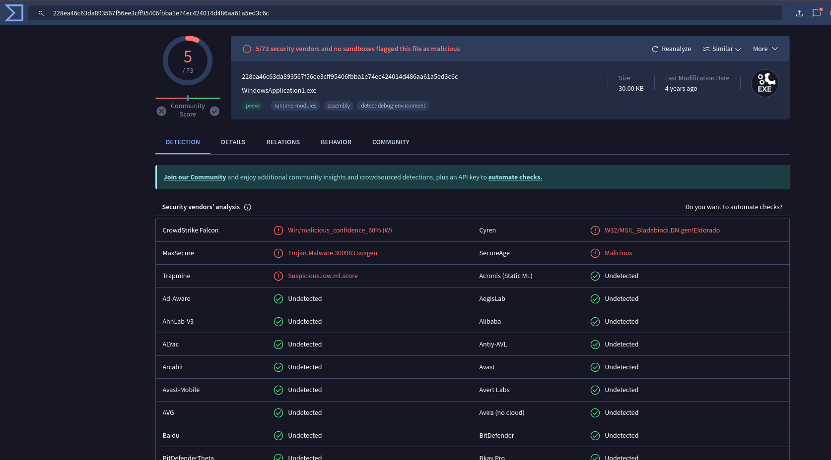

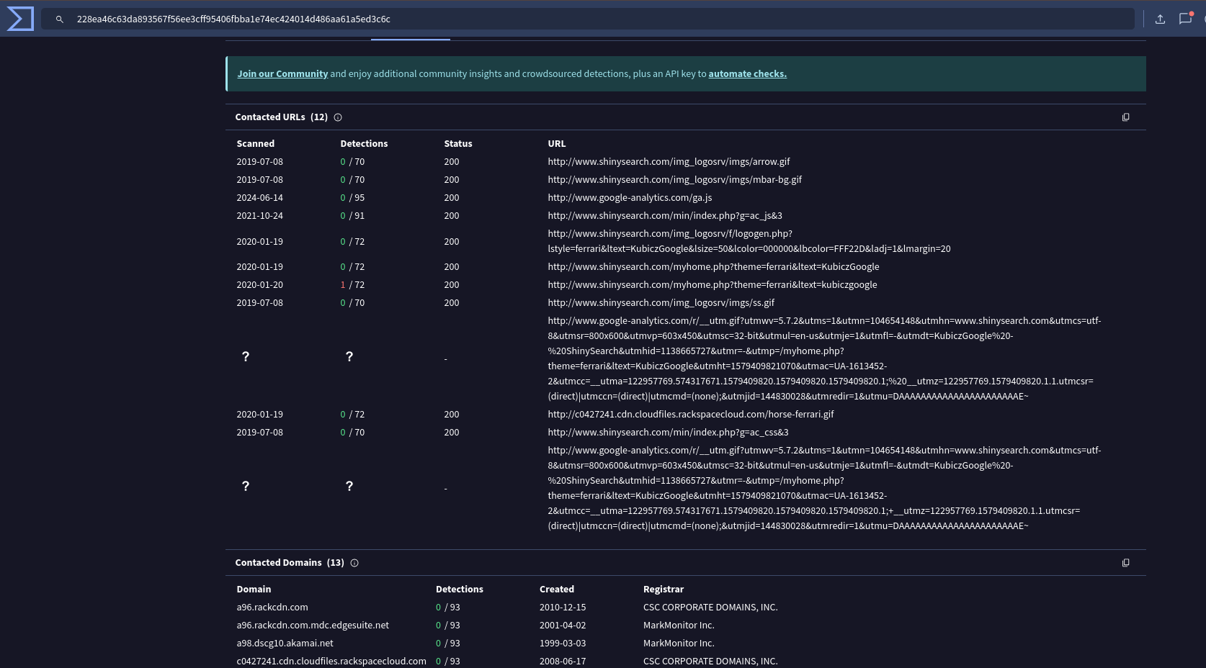

File 4

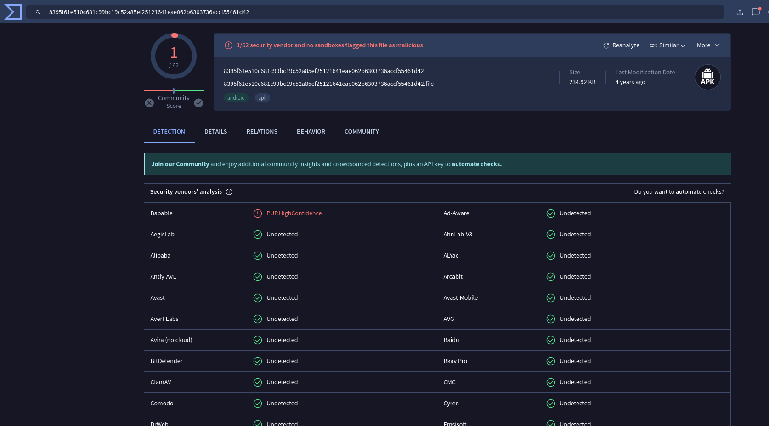

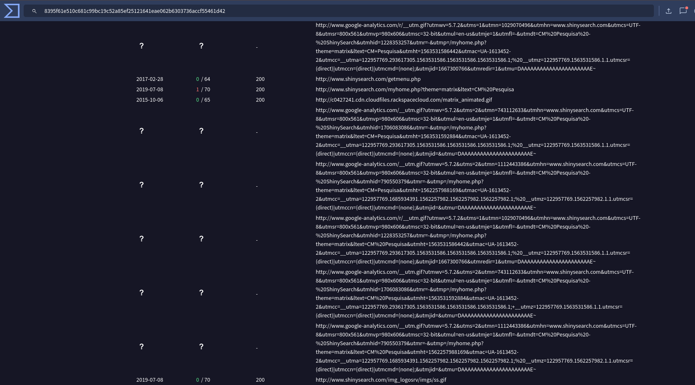

File 5

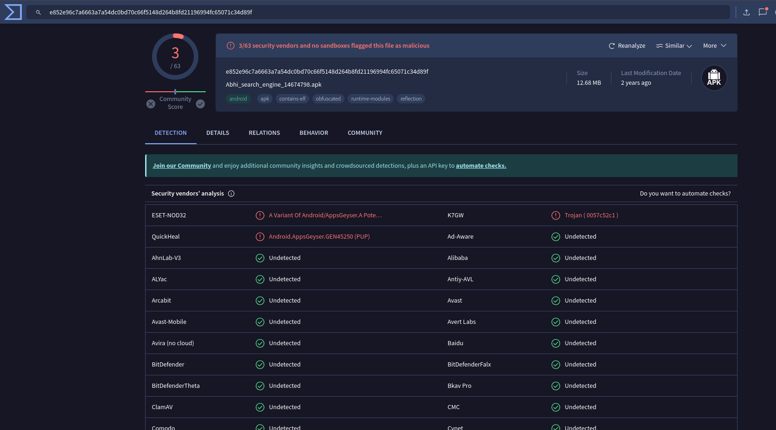

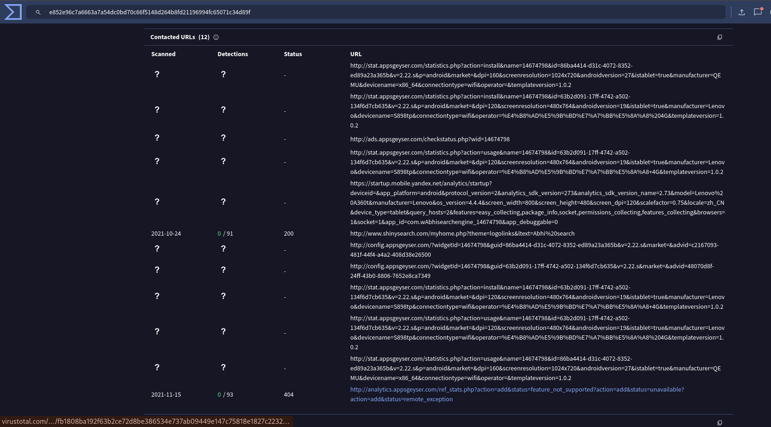

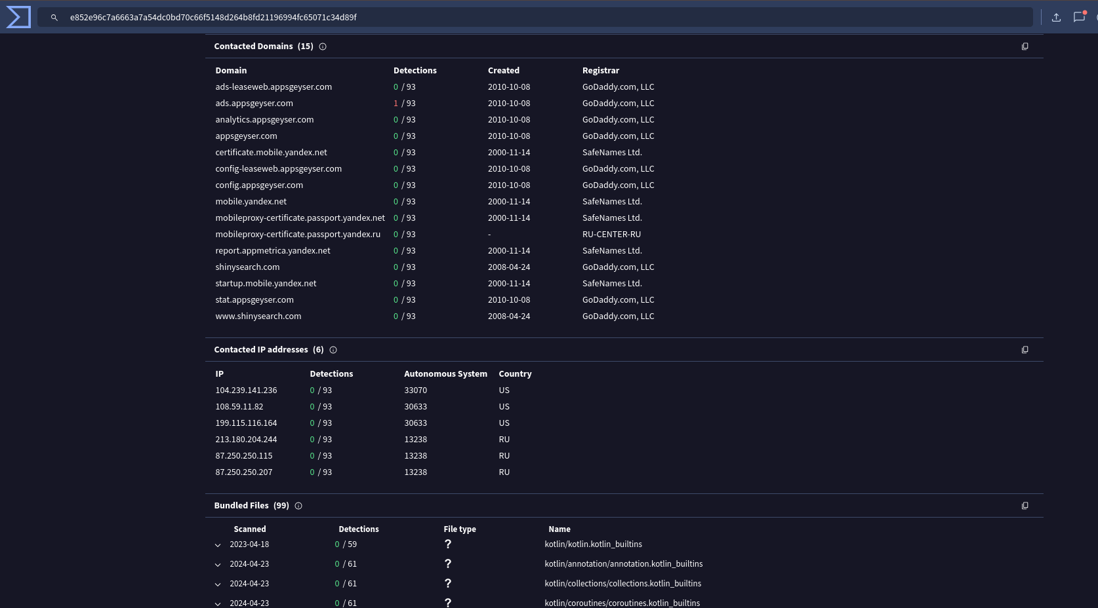

No further analysis required.